Give yourself, your company or a loved one permanent recognition at
The Alabama Music Hall of Fame

The We Believe in Music walkway surrounds the fountain in front of the museum, covered with bricks and granite stones with music stars, music fans and company names etched in them.

This permanent recognition allows thousands of people to see your brick or stone, year after year. AND, this is a 100% tax deductible donation to help the Alabama Music Hall of Fame!

We have three granite sizes available that can have the name you submit and or a logo etched on them and a normal brick for the name you submit.

A donation of $1,000.00 will get you a 16” x 8” granite stone.
A donation of $500.00 will get you a 8” x 8” granite stone.
A donation of $250.00 will get you a 4” x 8” granite stone.
A donation of $125.00 will get a normal size brick.
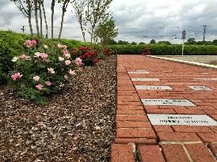
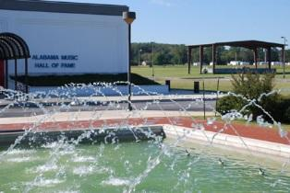
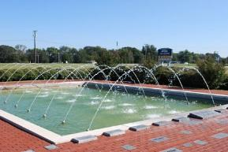

------------------------------------------------------------------------------------------------------------------------------------------
Purchased by:
Name: _______________________________ Company Name: _______________________________
Address: ______________________________ City: ____________________ State: _______ Zip: _____
Phone Number: _____________

I want:
_____ 16” x 8” Granite Stone(s) $1,000.00
_____ 8” x 8” Granite Stone(s) $500.00
_____ 4” x 8” Granite Stone(s) $250.00
_____ Normal Size Brick(s) $125.00

Method of Payment Circle One: Check
Amex MasterCard Visa Other: _____________
Name on Card: __________________________
Card Number: ___________________________ Expiration: _______ V-Code: ____

Check One:
Company Name & Logo (attached)
Company Name Only (shown above)
Other: ________________________________________________________

Send Your Donation and This Form To:
Alabama Music Hall of Fame
P.O. Box 740405
Tuscumbia, AL 35674

